**Solving the one-port calibration equations.**

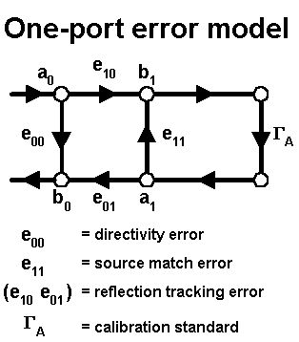

In a network analyzer one-port calibration, three standards are measured to determine the three error terms of the measurement system.  At first glance, it may appear that the set of three equations to be solved are nonlinear, but they can be manipulated into a set of three linear equations in three unknowns, as shown here.

Using the following notation (G is for gamma):

GA = actual reflection coefficient  
GM = measured reflection coefficient  
e00 = directivity error  
e10e01 = reflection tracking error  
e11 = source match error

The solution of the one-port measurement error model is:

GM = e00 + (e10e01) * GA / (1 - e11 * GA)

Let:

a = e10e01 - e00 * e11  
b = e00  
c = -e11

Then:

GM = (a * GA + b) / (c * GA + 1)  
or,  
GA * a + b - GA * GM * c = GM

Now measure the three known standards (GA1, GA2, GA3), and with the resulting three measurements (GM1, GM2, GM3), you have three linear equations to solve for a, b, and c:

GA1 * a + b - GA1 * GM1 * c = GM1  
GA2 * a + b - GA2 * GM2 * c = GM2  
GA3 * a + b - GA3 * GM3 * c = GM3

This works for any three standards, not just short, open, and load.